5G Mobile Analysis Track Evidence Workbook
  - H1 Quiet Exfil · H2 Replay or Retransmit · H3 Needle in the Handovers
Purpose: a reproducible lab record for the three PCAP investigations. The command examples and conclusions below reflect the terminal outputs shared during this session. Paste your own screenshots into the marked boxes, add captions, and complete the reflection prompts in your own words.

Challenge results at a glance
Challenge | Finding | Flag
H1 — Quiet Exfil | UDP length low nibble carries repeated 4-bit symbols | RFCTF{s1z3_1s_th3_m3ss4g3}
H2 — Replay or Retransmit | Stale Service Request: frame 96, UE ID 4217 | RFCTF{96_4217}
H3 — Needle in the Handovers | Final GUTI suffix 6b5a87ba; six distinct cells | RFCTF{6b5a87ba_6}

H1 Quiet Exfil
Question: recover a repeated message hidden as four bits per selected packet in the N3 user-plane capture. The README says the application payload is innocuous and gives a DEAD nibble synchronizer, so the investigation should test packet metadata and flow behavior rather than search payload text.

Step 1 — Identify a candidate flow
The unusual flow was isolated by its inner endpoints and UDP destination port. GTP-U wraps inner traffic, so tshark can show multiple outer/inner IP and UDP values; use occurrence controls or inspect one layer at a time when columns look concatenated.
tshark -r n3_userplane.pcap -Y 'ip.src == 10.60.12.37 && ip.dst == 203.0.113.47 && udp.dstport == 8853' -T fields -E header=y -E separator=/t -E occurrence=l -e frame.number -e frame.time_relative -e ip.src -e ip.dst -e ip.ttl -e ip.id -e ip.len -e udp.srcport -e udp.dstport -e udp.length -e gtp.teid | head -n 15

Decision: compare this flow with the capture’s other flows and inspect packet fields for a stable low-order pattern. The repeated candidate stream is the one to test against the four-bit channel and sync information in the challenge description.

Screenshot H1-A — flow and packet fields
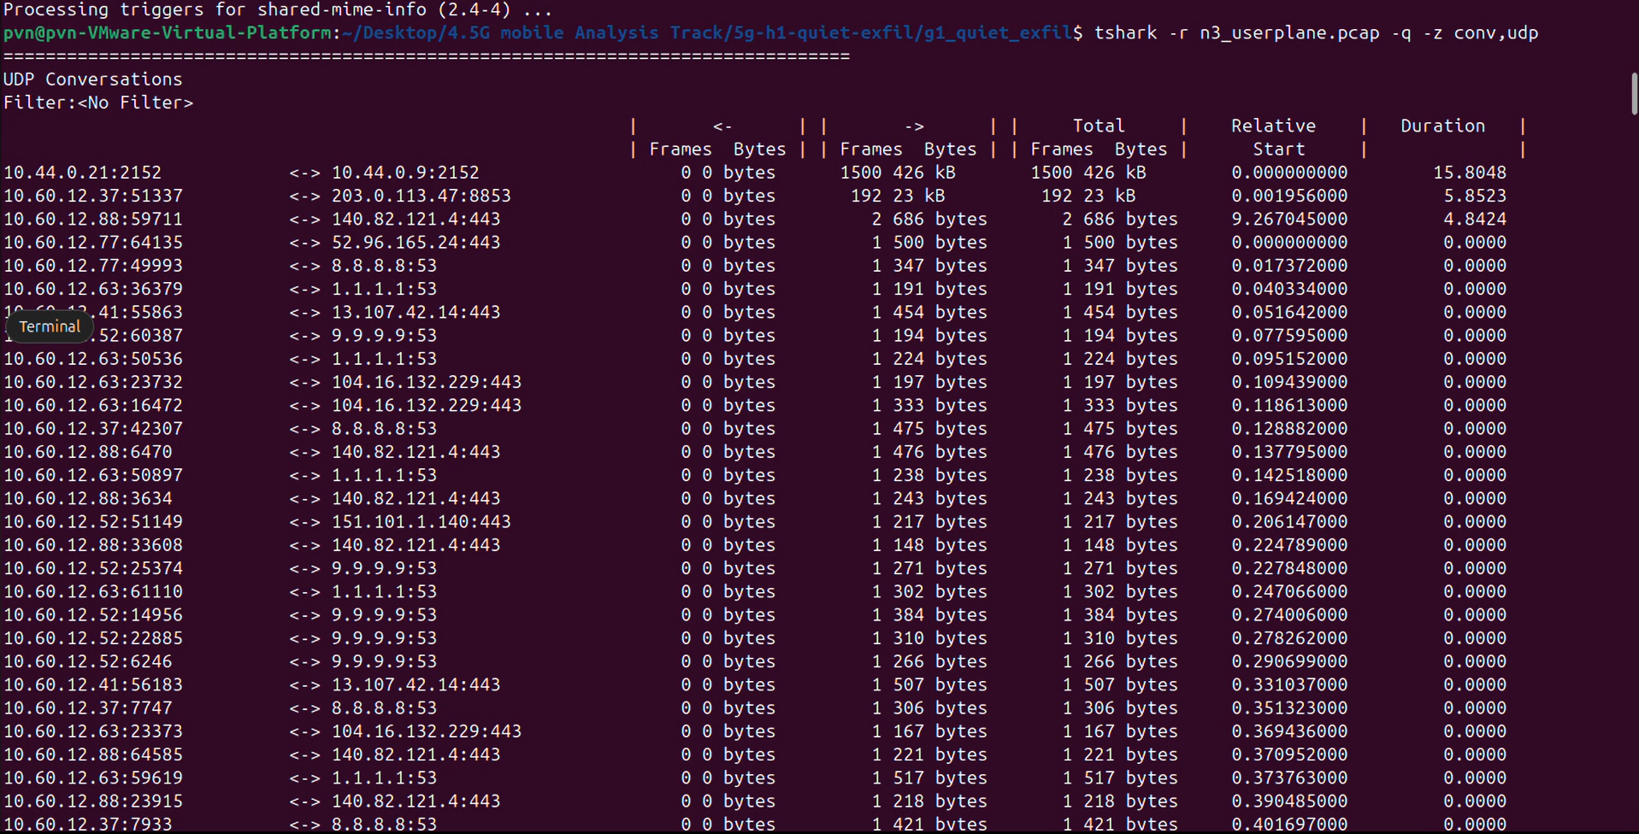
Caption / what this proves: ______________________________________________________________

Step 2 — Test which field carries the nibble
The inner IP length low nibble did not begin with the specified DE AD sync. The inner UDP length did: the first four symbols were D, E, A, D. This is the discriminating check that identifies the right metadata field.
tshark -r n3_userplane.pcap -Y 'ip.src == 10.60.12.37 && ip.dst == 203.0.113.47 && udp.dstport == 8853' -T fields -E occurrence=l -e udp.length | awk '{printf "%X", $1 % 16}'

A four-bit symbol is the remainder modulo 16. Formatting each remainder as hexadecimal makes the stream readable as nibbles; two consecutive nibbles form one byte, most-significant nibble first.

Screenshot H1-B — synchronizer
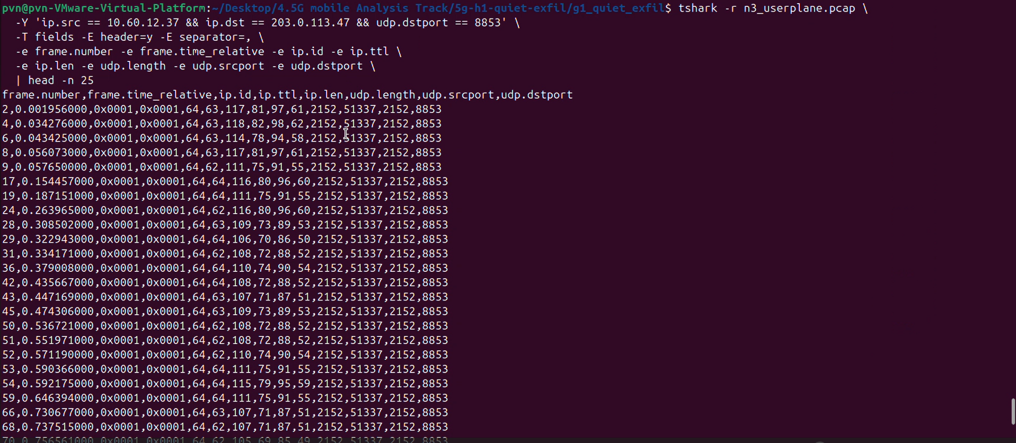
Caption / what this proves: ______________________________________________________________

Step 3 — Decode and verify
hex=$(tshark -r n3_userplane.pcap -Y 'ip.src == 10.60.12.37 && ip.dst == 203.0.113.47 && udp.dstport == 8853' -T fields -E occurrence=l -e udp.length | awk '{printf "%X", $1 % 16}')\nprintf 'Nibbles: %s\\n' \"$hex\"\nprintf '%s' \"${hex:4}\" | xxd -r -p\nprintf '\\n'

The decoded output contained the same readable RFCTF token repeatedly, bounded by framing characters, and the pattern repeated across the stream. Repetition plus the specified sync is stronger verification than a single plausible-looking decode.
Verified H1 result: RFCTF{s1z3_1s_th3_m3ss4g3}

Screenshot H1-C — decoded message
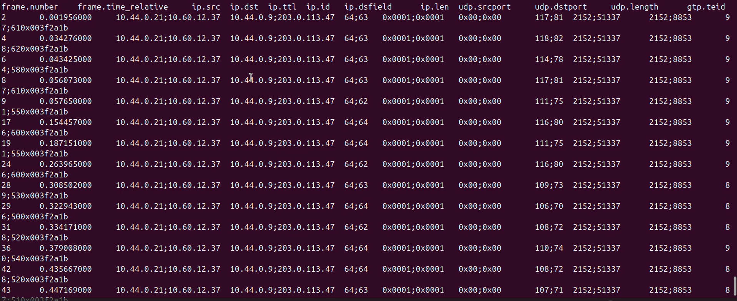
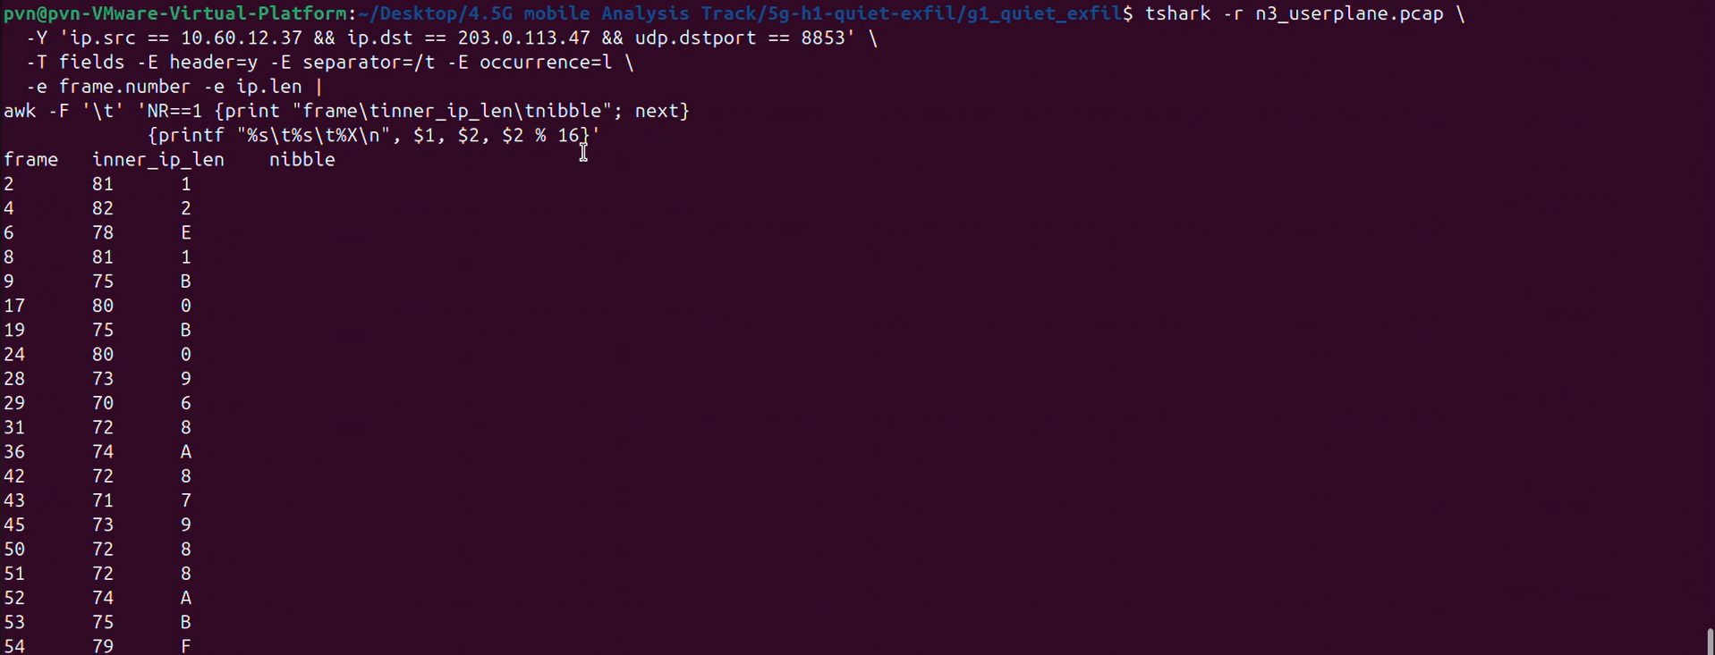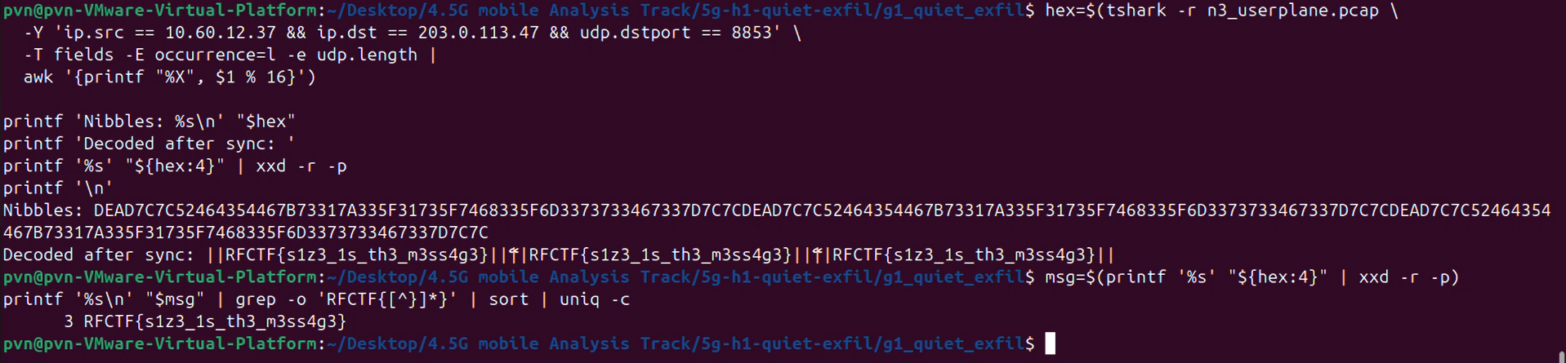
Caption / what this proves: ______________________________________________________________

Your own notes
What did I try first, and what did that result tell me?
________________________________________________________________________________________
________________________________________________________________________________________
Which clue changed my approach? Explain it in my own words.
________________________________________________________________________________________
________________________________________________________________________________________
What did I verify independently, and what would I correct in an earlier assumption or AI suggestion?
________________________________________________________________________________________
________________________________________________________________________________________

H2 Replay or Retransmit
Question: identify the injected uplink NAS message among byte-identical retransmissions. A duplicate packet alone is not proof: a legitimate subscriber may retransmit while waiting for a response. The deciding evidence is the subscriber’s NAS state when the duplicate arrives.

Step 1 — Parse the NASX header
The README defines a 16-byte header. Direction is byte 5; UE ID is bytes 6–7 (big-endian); message type is byte 8; sequence is byte 9. The captured payload is visible as hex in tshark’s data.data field.
tshark -r nas_signalling.pcap -Y 'udp.port == 9999' -T fields -E header=y -E separator=/t -e frame.number -e frame.time_relative -e data.data | head -n 12

The AWK parser built a TSV timeline named nas_index.tsv containing frame, time, direction, UE ID, type, sequence, and body length. For exact reproduction, use the offsets documented in the README; hex pairs are counted from byte zero.
tshark -r nas_signalling.pcap -Y 'udp.port == 9999' -T fields -E separator=/t -e frame.number -e frame.time_relative -e data.data | awk -F '\t' 'function hexdec(s, i,n,c){n=0;for(i=1;i<=length(s);i++){c=tolower(substr(s,i,1));n=n*16+index("0123456789abcdef",c)-1}return n} BEGIN{OFS="\t";print "frame","time_s","direction","UE_ID_decimal","type_hex","sequence","body_length"} {h=$3;dir=(substr(h,11,2)=="00")?"uplink":"downlink";printf "%s\t%s\t%s\t%d\t%s\t%d\t%d\n",$1,$2,dir,hexdec(substr(h,13,4)),substr(h,17,2),hexdec(substr(h,19,2)),hexdec(substr(h,29,4))}' > nas_index.tsv

Screenshot H2-A — parsed NAS timeline
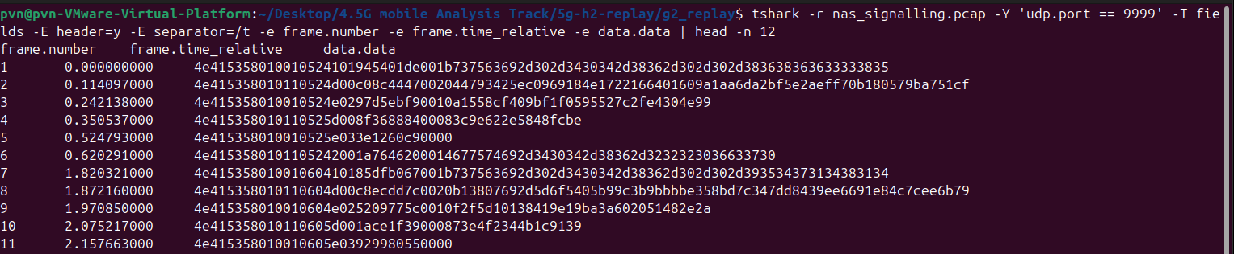
Caption / what this proves: ______________________________________________________________

Step 2 — Find duplicate uplink message identities
Group only uplink messages by UE ID, type, and sequence. Four repeated Service Request keys appeared. This creates candidates, not a final answer.
awk -F '\\t' 'NR>1 && $3==\"uplink\" {k=$4 FS $5 FS $6; n[k]++; f[k]=f[k] (f[k]?\", \" : \"\") $1 \"@\" $2} END {for(k in n) if(n[k]>1) print n[k] \"\\t\" k \"\\t\" f[k]}' nas_index.tsv | sort -t $'\\t' -k1,1nr

Candidate pairs: UE 4178 frames 26/34; UE 4192 frames 19/27; UE 4217 frames 48/96; UE 4238 frames 77/125. Identical content or a long delay does not by itself distinguish replay from retry.

Screenshot H2-B — duplicate candidates
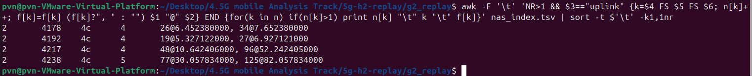
Caption / what this proves: ______________________________________________________________

Step 3 — Reconstruct state around each duplicate
Check surrounding uplink and downlink events for each UE. A legitimate retransmission is plausible while the request remains current and unanswered. The UE 4217 timeline shows a downlink Configuration Update after frame 48, then later uplink Service Requests at sequence 5 (frame 78) and sequence 6 (frame 92), each followed by a response. Frame 96 repeats its earlier sequence-4 Service Request after the UE had advanced.
awk -F '\\t' 'NR==1 || ($4==4217 && $1>=45 && $1<=100)' nas_index.tsv

As a byte-level cross-check, frames 48 and 96 had identical complete NASX payloads. This shows the later packet is a replay of the original bytes; the state timeline is what makes it suspicious rather than an ordinary retry.
tshark -r nas_signalling.pcap -Y 'frame.number == 48 || frame.number == 96' -T fields -E header=y -E separator=/t -e frame.number -e data.data

Verified H2 result: injected packet frame 96; AMF UE NGAP ID 4217. Flag: RFCTF{96_4217}

Screenshot H2-C — state and byte comparison
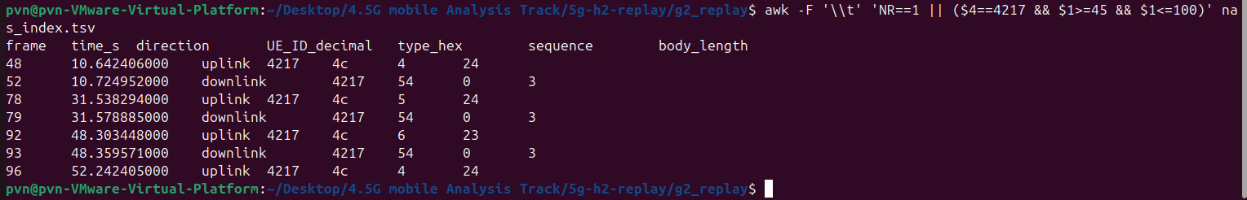
Caption / what this proves: ______________________________________________________________

Your own notes
What did I try first, and what did that result tell me?
________________________________________________________________________________________
________________________________________________________________________________________
Which clue changed my approach? Explain it in my own words.
________________________________________________________________________________________
________________________________________________________________________________________
What did I verify independently, and what would I correct in an earlier assumption or AI suggestion?
________________________________________________________________________________________
________________________________________________________________________________________

H3 Needle in the Handovers
Question: follow one subscriber across mobility events to report the final GUTI suffix and the number of distinct cells. RAN UE IDs are connection-scoped and recycled; the target’s SUPI anchors the first connection, while the GUTI bridges each later connection.

Step 1 — Locate the target identity
Decode the UDP payload from hex to ASCII and search for the specified SUPI. The capture contains the permanent identity once; that event identifies the connection RAN ID and initial cell.
tshark -r mobility_events.pcap -Y 'udp.port == 9801' -T fields -E separator=/t -e frame.number -e frame.time_relative -e data.data | while IFS=$'\\t' read -r frame time hex; do printf '%s\\t%s\\t' \"$frame\" \"$time\"; printf '%s' \"$hex\" | xxd -r -p; printf '\\n'; done | grep 'imsi-404861234591203'

Observed target identity: frame 9, RAN 00739. The starting registration at frame 8 places the target in NR-0E520. Do not follow RAN 00739 throughout the entire capture; it is reused by other subscribers.

Screenshot H3-A — target identity and initial registration
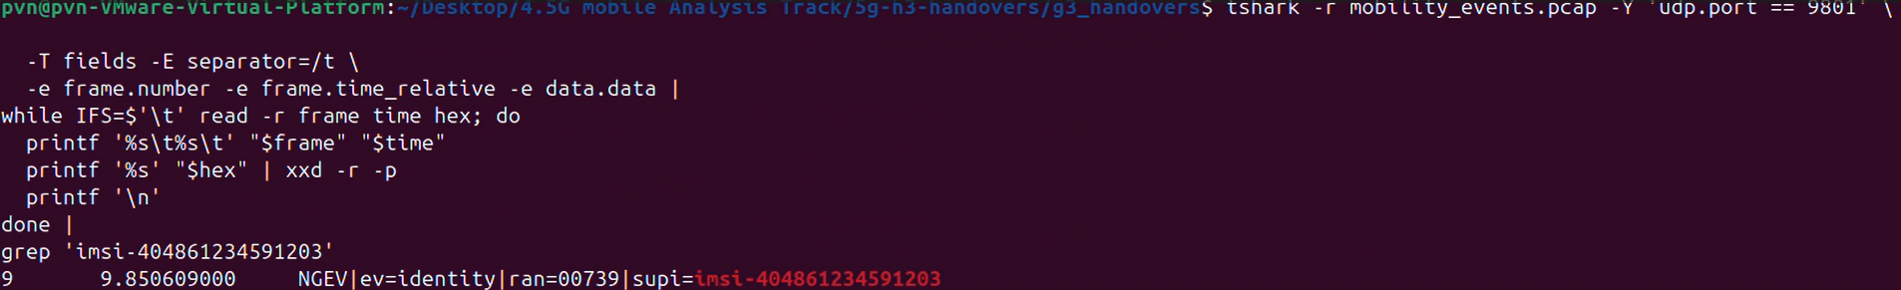

Caption / what this proves: ______________________________________________________________

Step 2 — Bridge connections using GUTIs
For each connection, follow its sequence: registration/service gives the starting cell, handover records add destination cells, realloc assigns the next GUTI, and release ends the connection. Search that exact GUTI to find the next service event, which may use a different RAN ID. Confirm the service event’s RAN belongs to the next connection and that the intervening identity belongs to a different subscriber before linking records.
# Example: search one newly allocated GUTI across the capture\ntshark -r mobility_events.pcap -Y 'udp.port == 9801' -T fields -E separator=/t -e frame.number -e frame.time_relative -e data.data | while IFS=$'\\t' read -r frame time hex; do printf '%s\\t%s\\t' \"$frame\" \"$time\"; printf '%s' \"$hex\" | xxd -r -p; printf '\\n'; done | grep -F '404-86-bfc596c9'

Documented chain from the event outputs: target GUTI bfc596c9 continues at frame 70; c7d3136f continues at frame 122; 3f034f96 continues at frame 171. Each GUTI search, not a global RAN grouping, links the target between connections.

Screenshot H3-B — GUTI handoff evidence
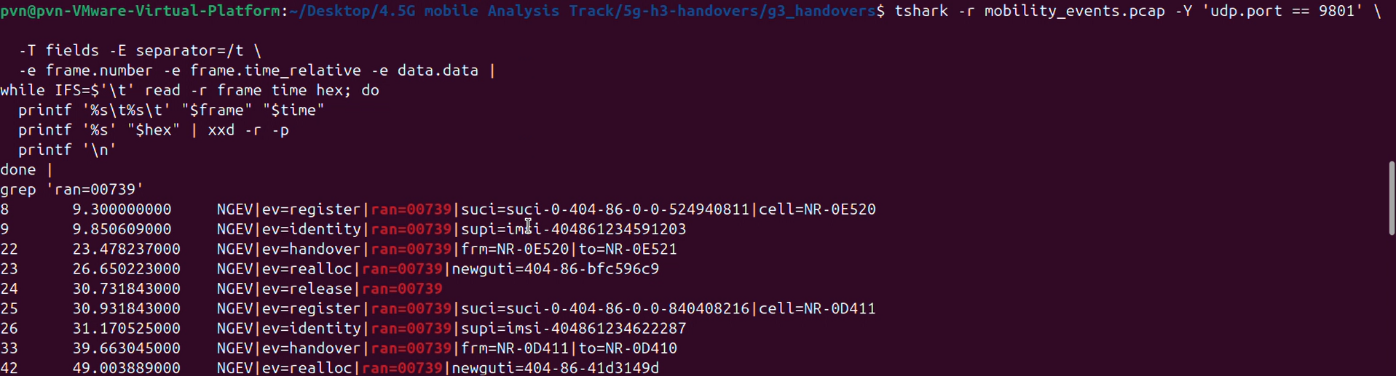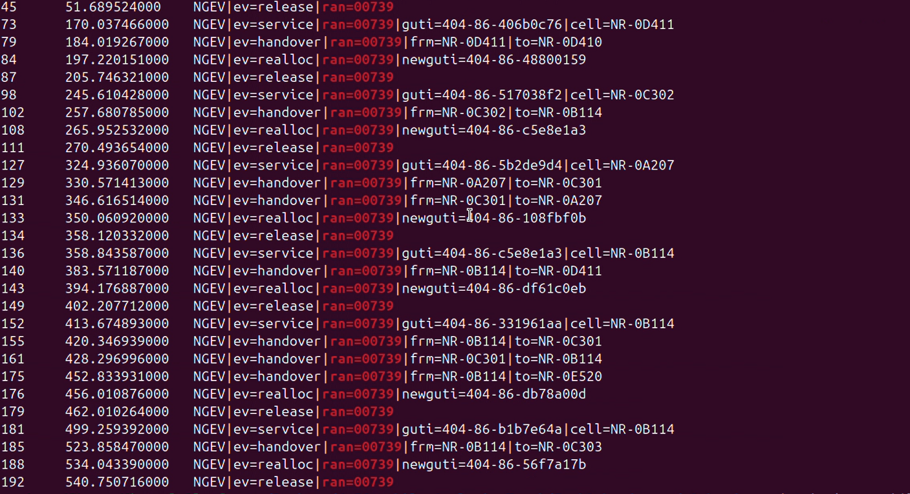
Caption / what this proves: ______________________________________________________________

Step 3 — Count cells and verify the final identity
Collect each connection’s starting cell and every handover destination, then deduplicate. The tracked target visited NR-0E520, NR-0E521, NR-0B115, NR-0A207, NR-0D410, and NR-0D411: six distinct cells. The last traced connection allocated GUTI 404-86-6b5a87ba at frame 178; the requested suffix is the final eight hexadecimal characters, 6b5a87ba.
The final GUTI’s realloc event is the last GUTI update seen for this target before the capture ends. The cell count includes both connection starting cells and handover destinations; revisits count once.
Verified H3 result: RFCTF{6b5a87ba_6}

Screenshot H3-C — final GUTI and cell set
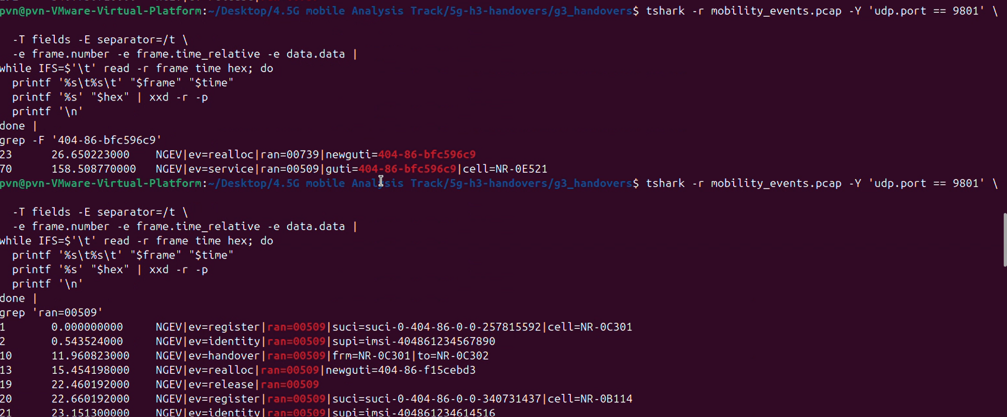
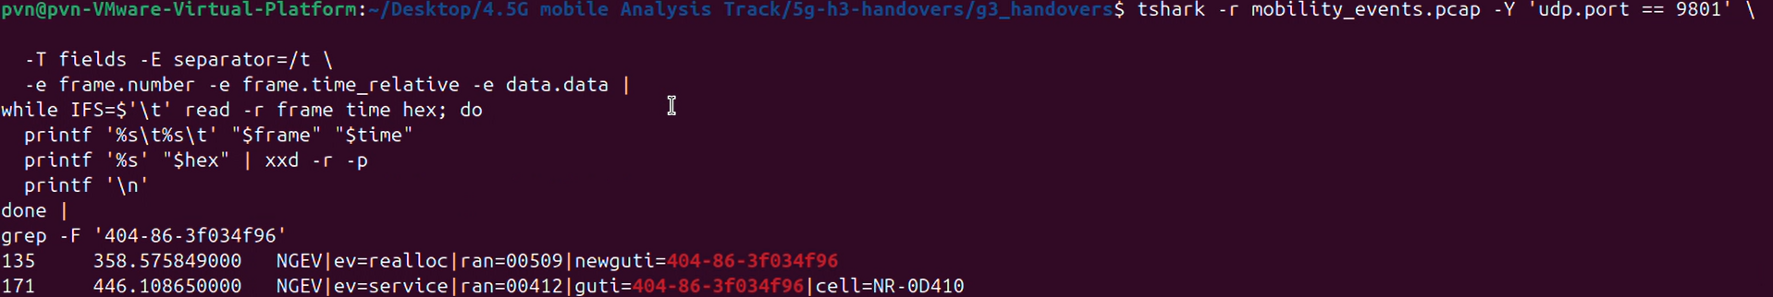
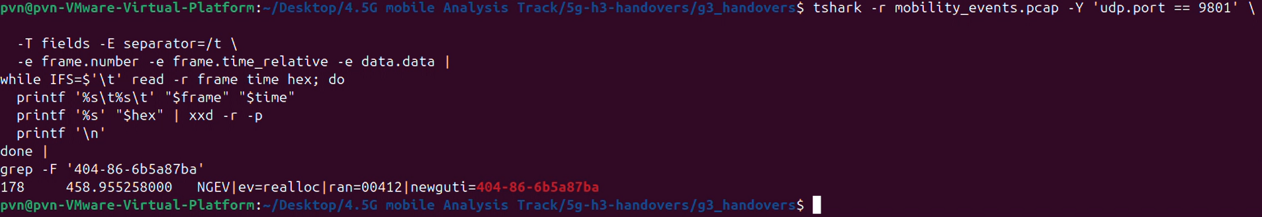

Caption / what this proves: ______________________________________________________________

Your own notes
What did I try first, and what did that result tell me?
________________________________________________________________________________________
________________________________________________________________________________________
Which clue changed my approach? Explain it in my own words.
________________________________________________________________________________________
________________________________________________________________________________________
What did I verify independently, and what would I correct in an earlier assumption or AI suggestion?
________________________________________________________________________________________
________________________________________________________________________________________

Reproduction and submission checklist
☐ My screenshots come from my own terminal or Wireshark session and show commands plus relevant output.
☐ I have checked every frame number, UE ID, GUTI, and cell against the original capture.
☐ I can explain why payload searching was the wrong first strategy in H1.
☐ I can explain why duplicate NAS bytes alone do not prove injection in H2.
☐ I can explain why RAN IDs cannot be followed across connections in H3.
☐ My personal reflection answers describe what I actually tried and corrected.
☐ I checked the event organizer’s authorship rules and wrote any required submission text myself.

Wireshark display filters
# H1 candidate inner traffic (field behavior depends on GTP-U dissection)\nip.src == 10.60.12.37 && ip.dst == 203.0.113.47 && udp.dstport == 8853\n\n# H2 exported NAS packets\nudp.port == 9999\n\n# H3 mobility event records\nudp.port == 9801

Terminal commands are the primary reproducible path in this workbook. Wireshark filters narrow the packet list; decoding the ASCII event or NASX payload still requires inspecting packet bytes or using the shown shell pipeline.

